H1: Most Experienced Real Estate Agent in Studio City

Description Under H1: Hiring a real estate agent in Studio City? Pick one who knows the block, not just the ZIP code. Studio City has many small markets, and the right price depends on your street. As one of the real estate agents in Studio City, CA, I price by pocket, negotiate with proof, and explain every step in plain words.

Buying in Studio City
I show you what your budget really buys: which pocket, which home type, and which school zone. Then I negotiate so you pay a fair price. Condos often start in the $600,000s to $700,000s, and houses often start near $1 million.

Selling in Studio City
Want to sell a house in Studio City? I start with a free home valuation based on sales from your own streets.
INVESTING:
I started in commercial real estate, so I run the numbers first: rents, costs, rules, and resale value. I look at duplexes, small apartment buildings, and development sites near the boulevard.

Studio City Real Estate, Street by street

Studio City sits where the Valley flats meet the Santa Monica Mountains. That splits the market into pockets, and I price each pocket on its own sales.
- LOCATION: Southeast San Fernando Valley, City of Los Angeles, just west of the Cahuenga Pass. Yes, Studio City is part of LA.
- PRIMARY ZIP: 91604. Some blocks sit in 91602 or 91607. I check the exact address before I pull sales, because the pocket matters more than the ZIP code.
- KEY CORRIDORS: Ventura Boulevard, Laurel Canyon Boulevard, Coldwater Canyon Avenue, Colfax Avenue, Moorpark Street, and Tujunga Avenue. The distance to these roads moves the price.
- LOCAL CHARACTER: A walkable stretch of Ventura, quiet tree-lined streets behind it, and private canyon and ridgeline streets above.
- HOUSING STOCK: Mostly single-family homes. I match sales by home type, not just size: 1920s to 1940s character homes and ranches in the flats, mid-century and modern homes in the hills, and condos near the boulevard.
- BORDERING AREAS: Sherman Oaks, Valley Village, North Hollywood, Toluca Lake, the Hollywood Hills, and Woodland Hills. If you shop in those areas too, I compare them with you.

Living in Studio City: What to Know Before You Buy
Where a home sits next to the boulevard, the hills, and the canyon roads shapes daily life and price. Here is what I check with each client.
01. Ventura Boulevard & the Village
The stretch around Ventura Place is the closest thing Studio City has to a downtown, with independent restaurants, cafes, boutiques, and a Sunday farmers market. Homes within walking distance cost more and hear some boulevard noise. I help you decide if that trade is worth it.
02. The Residential Flats
Quiet, tree-lined streets sit behind the boulevard. Pockets such as Colfax Meadows hold 1920s to 1950s homes on regular lots. I compare each house with sales on its own blocks, because one street can price differently from the next.
03. Hillside & Canyon Streets
Streets climb toward Mulholland Drive with bigger lots, views, and narrow roads. I check road access, retaining walls, and fire insurance early, so you have no surprises after you fall for a view.
04. Parks & Outdoor Access
Wilacre Park, Fryman Canyon Park, and Beeman Park are close, and a path runs along the LA River on the north side. I show you how close each home is, and how that shows up in the price.
05. Commute & Connectivity
The 101 freeway, Ventura Boulevard, and the Metro B Line station link you to Burbank, Hollywood, and downtown. Laurel Canyon Boulevard crosses to West Hollywood. I help you test your real commute before you offer.
06. Entertainment Industry Access
Mack Sennett built a studio here in 1927, and today it is Radford Studio Center, formerly CBS Studio Center. If you work in film, TV, or music, I help you weigh the Universal City and Burbank commute.
Photo caption (unchanged): The Village & Ventura Place. Walkable dining, independent boutiques, and a weekly farmers market.
Search band:
Ready to see Studio City homes for sale?
Search every active Studio City listing on my MLS, from condos to hillside homes. When one looks right, I tell you what it should really sell for. [Search My MLS]

What Can You Buy in Studio City?
Seven kinds of homes. Here is how I help with each one.
- MOST COMMON: Single-Family Homes. Houses for sale in Studio City, CA often start near $1 million. I match each house to the right set of sales, so you don’t overpay or underprice.
- ENTRY POINT: Condos & Townhomes. Studio City condos for sale cluster along and just off Ventura, often in the $600,000s to $700,000s. I review HOA fees, reserves, and rules before you write an offer.
- CHARACTER: Mid-Century Homes. Post-and-beam frames, walls of glass, and indoor-outdoor living. I check original wiring, windows, and records, so you know what is charming and what is cost.
- DESIGN-LED: Modern & Architectural. New builds and big remodels, mostly in the hills. I check the permits and the build quality behind the finish.
- VIEWS: Hillside Properties. View lots on winding streets, often built in steps. I check walls, drainage, and road access before price talks.
- UPPER TIER: Luxury Homes. Large new builds and estates in the hills and the Longridge area. I price them on views, lot size, and the few true comparables.
- INCOME: Multifamily & Income. Duplexes through small apartment buildings, mostly near the boulevard. I check rents, rent rules, and repair costs, and I test the numbers with my commercial background.

Studio City Homes for Sale and Recently Sold
Browse homes for sale in Studio City, CA from my MLS feed, followed by recent sales. Select any home to see photos, price, beds, baths, and square footage.

(Cards unchanged.)

Local Places & Daily Rhythm ( Remove this section from the page)
The places I point clients to first.
- Dining: Independent restaurants line Ventura Boulevard, with a second cluster on the Tujunga Village strip. The Sunday farmers market meets at Ventura Place. I tell buyers which blocks put it a short walk away.
- Shopping & Services: Groceries, a pharmacy, fitness, and daily services sit along the boulevard. Larger stores are a short drive toward Sherman Oaks or Universal City.
- Parks & Recreation: Wilacre Park and Fryman Canyon Park have trails. Beeman Park serves the flats. The LA River path runs along the north side.
- Schools & Institutions: LAUSD schools here include Carpenter Community Charter (K-5), Rio Vista Elementary (K-5), and Walter Reed Middle School (6-8). Private options include Oakwood and Campbell Hall. I help you confirm the school zone for each
Why Work With Andrew, Your Studio City Realtor
People often search for the most experienced real estate agent in Studio City or the most recommended real estate agent in Studio City. A title can't prove either one. Proof can, and here is mine.
- Local roots: My office is on Ventura Place. My recent Studio City sales run from a $775,000 condo to a $3.8 million home.
- Clear numbers: I started in commercial real estate, so I check the numbers behind every deal and show you the sales behind every price.
- Strong negotiation: I am a Certified Real Estate Negotiation Expert, RealTrends Verified, and a Los Angeles Magazine Real Estate All-Star.

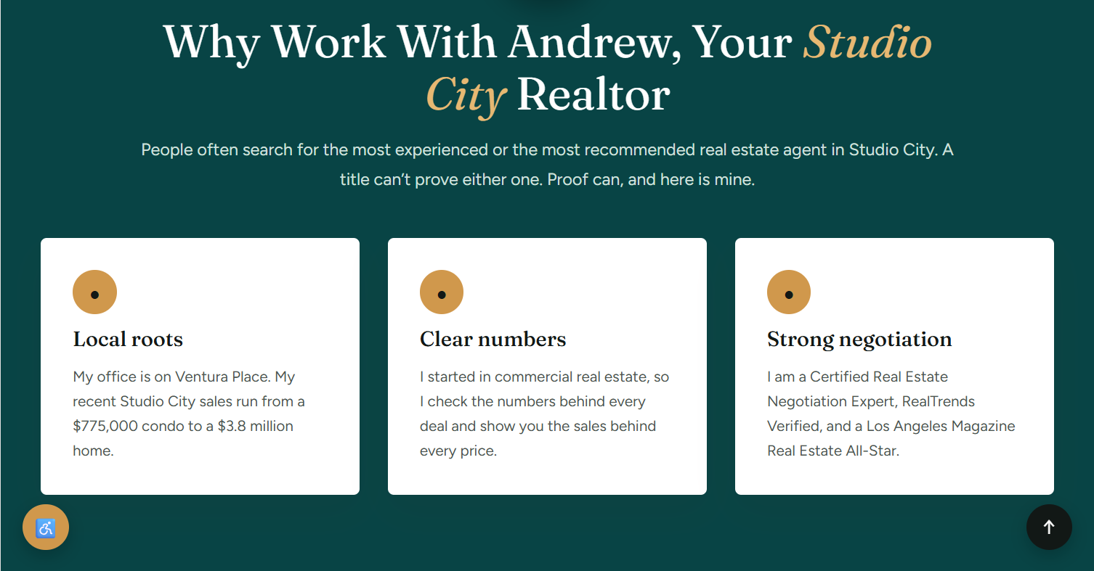

How I Work With Clients
Six steps from first call to closing, built around your street.
- Consultation: We talk about your goals, your timing, and which Studio City pocket fits.
- Strategy: I compare sales on your streets before any move.
- Search or Pricing: A curated search, or a price built on your pocket’s recent sales.
- Negotiation: Certified skill on price, repairs, and terms.
- Closing: Escrow, inspections, and paperwork handled.
- Ongoing: Advice on value long after closing.
Frequently Asked Question
- How do I choose a real estate agent in Studio City? Ask how many Studio City homes the agent sold in the last 12 months, and which sales they would use to price yours. Ask for proof, not titles like “top” or “best.” Check licenses, reviews, and how clearly they explain each step.
- How do I choose an agent as a first-time buyer in Studio City? Pick someone who explains the process in plain words and shows you both condos and houses. Studio City condos often cost less than houses, so compare both before you decide.
- How much does a real estate agent cost in Studio City? Agent fees are negotiable. Total commissions often run about 5% to 6% of the sale price. Ask for the fee in writing before you sign.
- How much does a home cost in Studio City? Zillow shows a median sale price near $1.64 million, and Resideline shows about $1.78 million over the last six months in ZIP 91604. Condos often start in the $600,000s to $700,000s, and houses often start near $1 million. Hillside and luxury homes reach $3 million and up.
- How do I find my home’s value before I sell a house in Studio City? Start with recent sales from your own pocket. Then adjust for lot size, view, condition, and updates. I do this in a free valuation. Online estimates often miss these details.
- What should sellers know about the current market? On October 5, 2026, Resideline counted 64 active listings and 3 pending sales in ZIP 91604, which it reads as a balanced market. Zillow shows homes going pending in about 40 days. Asking prices run above sold prices, so price against recent sales, not other listings.
- What types of homes can I buy in Studio City, and where? Mostly single-family houses: traditional and ranch homes in the flats, and mid-century and modern homes in the hills. Condos and townhomes sit near Ventura Boulevard, and duplexes and small apartment buildings sit near the boulevard and the eastern edge.
- How does Studio City compare with Sherman Oaks? Studio City often costs more and has a village feel along Ventura Boulevard. Sherman Oaks often costs less, and Ventura splits it into flat streets to the north and hills to the south.
- What is the ZIP code for Studio City, and is it part of LA? The main ZIP code is 91604. Some blocks use 91602 or 91607. Yes, Studio City is a neighborhood in the City of Los Angeles, just west of the Cahuenga Pass.

Buying or Selling in Studio City?
Tell me your street, your timing, and your goal. I’ll tell you what the market means for your next move. Free consultation. No pressure.
Buttons: Browse Studio City Homes · Get Your Home Value

Page tags
- Title: Real Estate Agent in Studio City | Andrew Liberty (49 characters)
- Meta description (145 characters): Real estate agent in Studio City: Andrew Liberty helps buyers, sellers, and investors with local knowledge, housing types, and market conditions.

